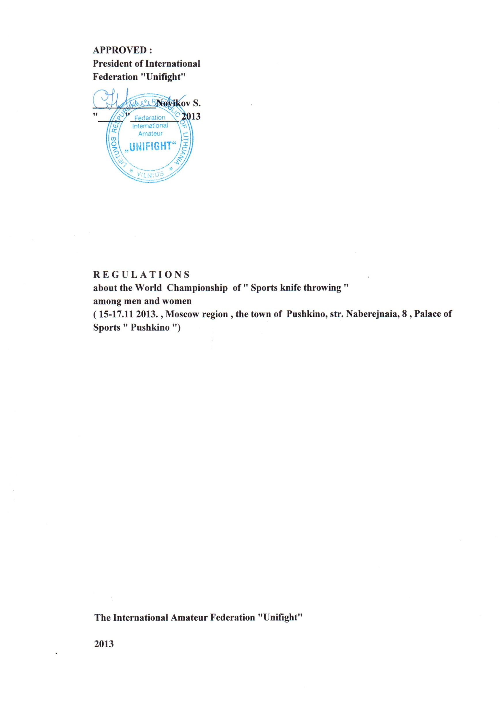

**1. Goals and Objectives**  
• To determine the winners in the individual and the absolute championship  
• Promotion of applied exercise "Sports knife throwing "  
• The competition is held for the purpose of further development of the "Unifight" in the countries of the world.  
• Activities of the National Federations "Unifight " with young people.  
• To share experiences , expertise and organization of the competition on " Sports knife throwing"  
**2 . Date and place of the event**Competitions are held from 15th to 17th November,2013 in Pushkino, Russia .  
**3 . Guide the preparation and conduct of the competition** .  
1. Common questions of preparation and organization of events related to the competitions: the reception and placement of teams , catering , transportation services , and the preparation and installation of stands for a throwing knife , providing secretariat office equipment , attracting the media to cover events and other organizational matters assigned to the Organizing Committee of the Championship .  
2 . The direct holding of the World Championship competition rests on the main panel of referees approved by the President of FIAU .  
3 . Head referee - International referee "B" class Lukash Igor ( Russia )   
The Chief Secretary - International referee Class "C" – Kolosov Alexander (Russia)  
   
**4.The requirements for the composition of teams , participants and conditions of the competition.**  
**The competitors:**National federations complement the team of men and women  
**Program:**  
- Women - race 3m and 5m. , the absolute championship ;  
- Men - distance 5,7 and 9 meters. , the absolute championship ;  
  
**November 15 , Friday:**  
17.00 - Arrival of participants in the World Championship , and registration.  
17.00 - 19.00 - the work of the Credentials Committee , the draw of participants;  
19.00 - 20.00 - referee seminar , a meeting of representatives of the teams in the next few days - at the end of the day the competition;

**November 16 , Saturday :**10.00 - 18.00 - preliminary competitions ( 5 series of 3 shots )  
- At a distance of 3 m for women ;  
- At a distance of 5 m for women ;  
- At a distance of 5m for men;  
- At a distance of 7 m for men;  
- At a distance of 9 m for men;  
18.00 - Opening ceremony ;

**November 17 , Sunday :**  
10.00 - 14.00 - finals (10 series of 3 shots )  
- At a distance of 3m for women;  
- At a distance of 5 m for women ;  
- At a distance of 5m for men;  
- At a distance of 7m for men;  
- At a distance of 9m for men;  
15.00 - 17.00 - absolute championship among women and men.

After the competition - award ceremony , closing ceremony of the World Championship . The departure of teams.  
  
**5.The order of drawing of lots**1. The draw for the participants in each category of the total , is held on the day of arrival.  
 In the 2nd and 3rd round of the competition , the participants of the exercises , according to their results in the previous round - from the worst to the best results .  
2 . Nominal application is available to the credentials committee the day of arrival . Provisional application - the size of the sports delegation will be sent 20 days before the start of the Championship Organizing Committee .  
**Presentation of the team members**  
The team leader is a request to the credentials committee established form , proof of identity , proof of insurance for each participant in an accident at the time of the competition  
  
**6 . The participants of the Championship.**For Sportsmen - men and women who know how to handle a knife Unifight-pro, Unifight-pro-L FIAU approved sample , knowing rules of sports knife throwing and licensed physician to participate in these competitions.  
Uniform of participants: black pants , a white shirt with short sleeves - T-shirt, sports shoes.  
Uniform of the referees: a white shirt with short sleeves, black tie - a butterfly , black pants, black socks, black athletic shoes .  
  
**7. Conditions of the competition .**  
Competitions are held at 3 circles :  
- In the first round ( pre- competition) involves all the athletes admitted to the competition , which perform exercises at distances 3,5,7 meters from the formula: 5 series of 3 shots in their respective age categories.  
- If, after three series of three shots at the sportsman no effective hitting , he is disqualified ;  
- The second circle - the finals at distances permitted by the top 8 participants in each of the first round of exercises that challenge prizes in separate exercises at the same time determined by the 4 finalists to participate in the absolute superiority in each age category.  
- In the third round ( the absolute championship ) competitions in the top 4 players ( on the amount of exercise at distances corresponding to each group) contest the title of absolute champion , doing all the exercises one after the other by the formula: 10 series of 3 shots .

**8. Determination of winners .**  
The winners and prize-winners in each type of program events are determined by the highest number of points.  
In case of a tie in biathlon and triathlon with two or more participants over the place by the participants with the best result in 3 (2 ) exercise in the final.  
  
**9. Terms of financing .**Transportation costs and the costs for accommodation and meals at the hotel , visa clearance competitors are sending organizations and national federations .  
**For members:**  
Hotel accommodation in the Hotel "Baikonur " , 750 rubles a day ;  
**For fans of :**  
Hotel accommodation in the Hotel " Baikonur " , 750 rubles a day ;  
Delivery athletes to the event and back is centralized .  
Accreditation of athletes in the Championship - 100 USD  
  
**10. Organizational issues.**  
1. This Regulation is the official invitation to the World Championship .  
2. participating teams countries need to have 2 national flags and the national anthem on CD for the ceremonies , openings, closing ceremony , awarding of prizes.  
3.the confirmation of participation (or reject) must be notified not later than the 1st November, 2013.  
4 . To ensure timely entry visa to Russia for foreign participants Championships must confirm their participation no later than the 1th October 2013 with passport data ( photocopies of passports ) of all the members of the delegation, place of work (study ) , titles, addresses , work and home phone number.  
5.Sport delegation arriving for the World Championship should inform the date, time and flight number or train.  
6.Carrige the knives to the competition must not contradict the Russian law . A copy of the certificate of conformity can be obtained from the Russian Federation "Unifight" and have it in transit knives.  
7.Transport to the competition :  
The address of the championship : the Moscow region , the town of Pushkino, Palace of Sports “Pushkino "  
Residence address command : Moscow Region. , the Pushkino district, the Hotel " Baikonur "  
Contact phone numbers in the Hotel " Baikonur : 8 ( 800) 200-96-80  
Contact numbers for inquiries in Moscow : +7 ( 495) 912 27 31 (fax ) 912 90 57 , www.unifight.ru www.unifight.com E-mail: unifight1@mail.ru